SEMESTER TWO
Papers written by Australian Maths Software

YEAR 11
MATHEMATICS SPECIALIST
Units 1 & 2
2016
REVISION 2
Section Two
(Calculator–assumed)

Name: __________________________________

Teacher: ________________________________

TIME ALLOWED FOR THIS SECTION

Reading time before commencing work: 10 minutes
Working time for section: 100 minutes

MATERIAL REQUIRED / RECOMMENDED FOR THIS SECTION

To be provided by the candidate
Standard items: pens, pencils, pencil sharpener, highlighter, eraser, ruler.

Special items: drawing instruments, templates, notes on up to two unfolded sheets of A4 paper, and up to three calculators approved for use in examinations.

IMPORTANT NOTE TO CANDIDATES
No other items may be taken into the examination room. It is your responsibility to ensure that you do not have any unauthorised notes or other items of a non–personal nature in the examination room. If you have any unauthorised material with you, hand it to the supervisor before reading any further.

To be provided by the supervisor
Question/answer booklet for Section Two.
Formula sheet retained from Section One.
Structure of this examination

 | Number of questions available | Number of questions to be answered | Working time (minutes) |  | Marks available | Percentage of exam
Section One  Calculator—free | 6 | 6 | 50 |  | 52 | 35
Section Two  Calculator—assumed | 12 | 12 | 100 |  | 98 | 65
Total marks |  |  |  | 150

Instructions to candidates

1. The rules for the conduct of this examination are detailed in the Information Handbook. Sitting this examination implies that you agree to abide by these rules.

2. Write your answer in the Question/Answer booklet.

3. You must be careful to confine your responses to the specific questions asked and to
follow any instructions that are specific to a particular question.

4. Spare pages are provided at the end of this booklet. If you need to use them, indicate in the original answer space where the answer is continued i.e. give the page number.

5. Show all your working clearly. Your working should be in sufficient detail to allow your answers to be checked readily and for marks to be awarded for reasoning. Incorrect answers given without supporting reasoning cannot be allocated any marks. For any question or part question worth more than two marks, valid working or justification is required to receive full marks. If you repeat an answer to any question, ensure that you cancel the answer you do not wish to have marked.

6. It is recommended that you do not use pencil, except in diagrams.

7. The Formula Sheet is not to be handed in with your Question/Answer booklet.

Section Two: Calculator–assumed 98 marks

This section has thirteen (13) questions. Attempt all questions.
Working time: 100 minutes
Question 7 (7 marks)
(a) Given a normal pack of 52 cards containing 4 different suits how many cards will need to
be drawn at random to ensure at least two cards are from the same suit? Explain. (2)

(b) (i) In how many ways can 6 Year 7 students be selected from 10 girls and 10 boys?
(1)

(ii) In how many ways can 6 Year 7 students be selected if only girls can be selected? (1)

(c) How many of the counting numbers from 1 to 100 have both a factor of 2 or 3 but not a factor of 6? (3)

Question 8 (9 marks)
(a) Simplify 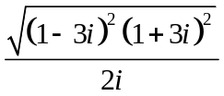 (3)

(b) If 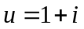 and 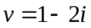
find
(i) 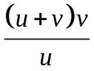 (3)

(ii) 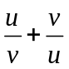 (3)

Question 9 (4 marks)
Three ten year old girls are trying to move a wardrobe. Two push from either side and one pushes in the middle in the direction they want to move the wardrobe.

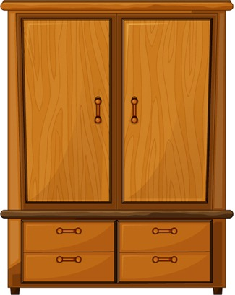
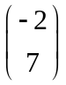
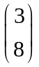
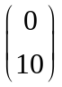

The forces exerted by the young girls are shown in the diagram above.
(a) What is the resultant force? (2)

(b) Determine the magnitude and direction of the resultant force. (2)

Question 10 (6 marks)
(a) Solve for and , giving reasons. (3)
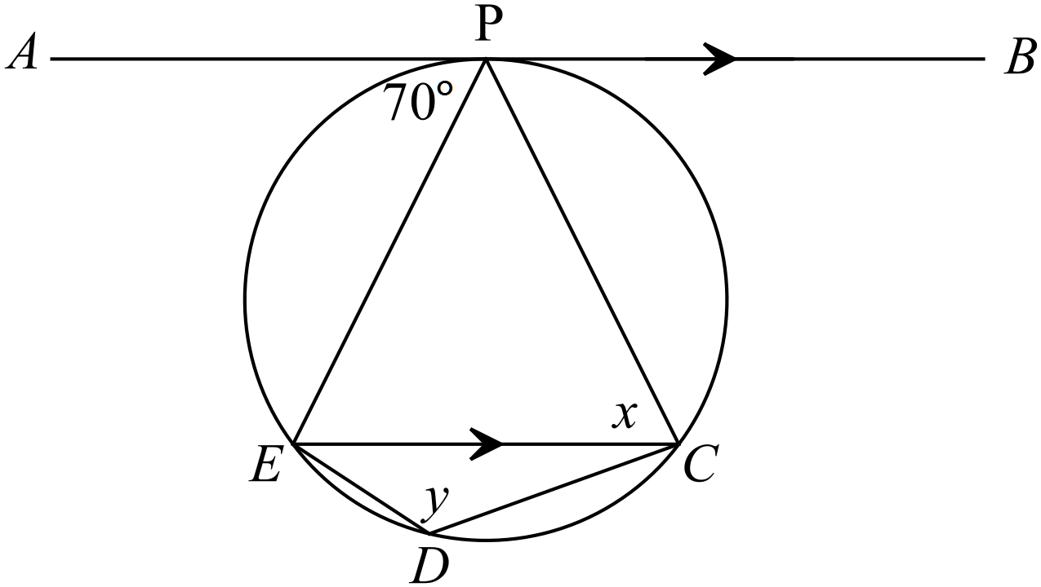

(b) Solve for and , giving reasons. (3)

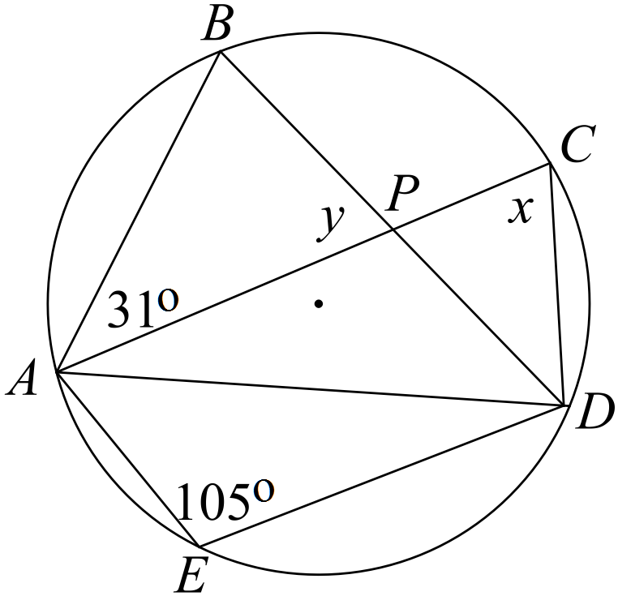

Question 11 (13 marks)

(a) (i) Show how 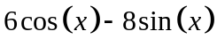can be expressed in the form 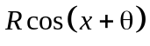for
a value of  and such that R > 0 and 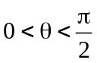. (3)

(ii) Hence sketch 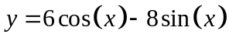 on the set of axes below on the domain 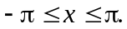
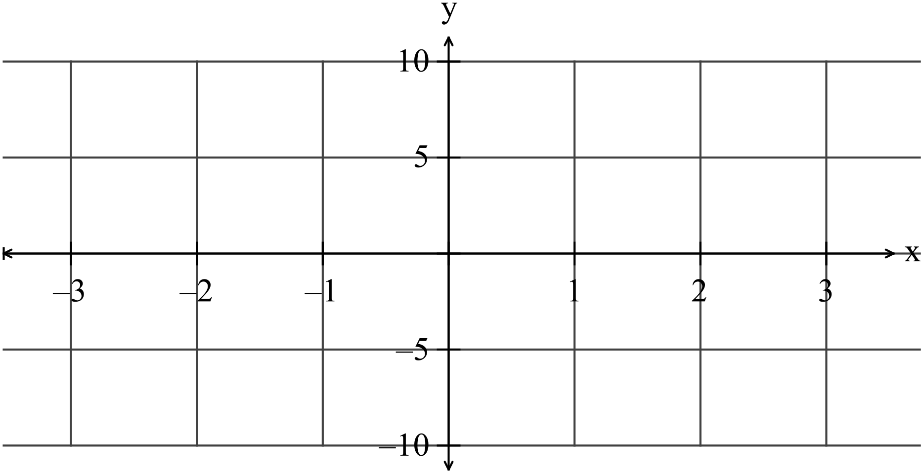

(2)

(b) Write down the equation of the function graphed below. (3)
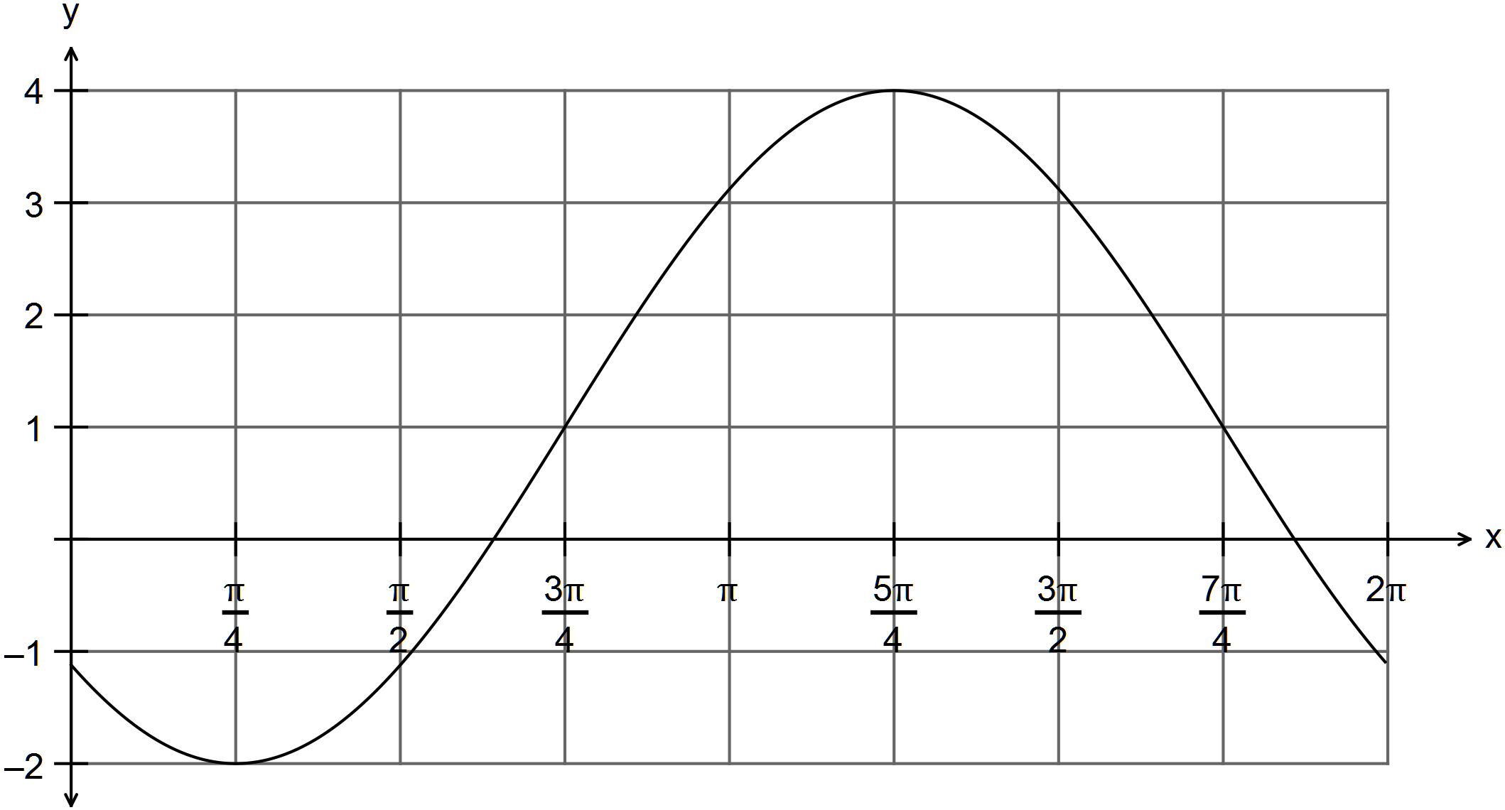

(c) Given 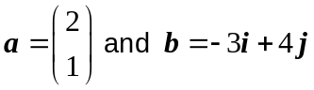, find
(i) 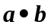. (1)

(ii) 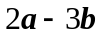 (2)

(iii) the vector parallel to but with magnitude equal to 10 . (2)

Question 12 (8 marks)

The number of hours of daylight over a year (365 days) can be approximated using a sine or cosine function. The shortest day of the year is June 21 with 8 days of daylight. The longest day of the year is December 21st that has approximately 14 hours of daylight.
Let be the counter of days in the year. (Assume there are 365 days in the year).
The function that models this data is 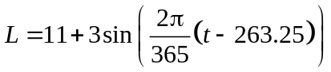
(a) Sketch the function on the set of axes below. (4)

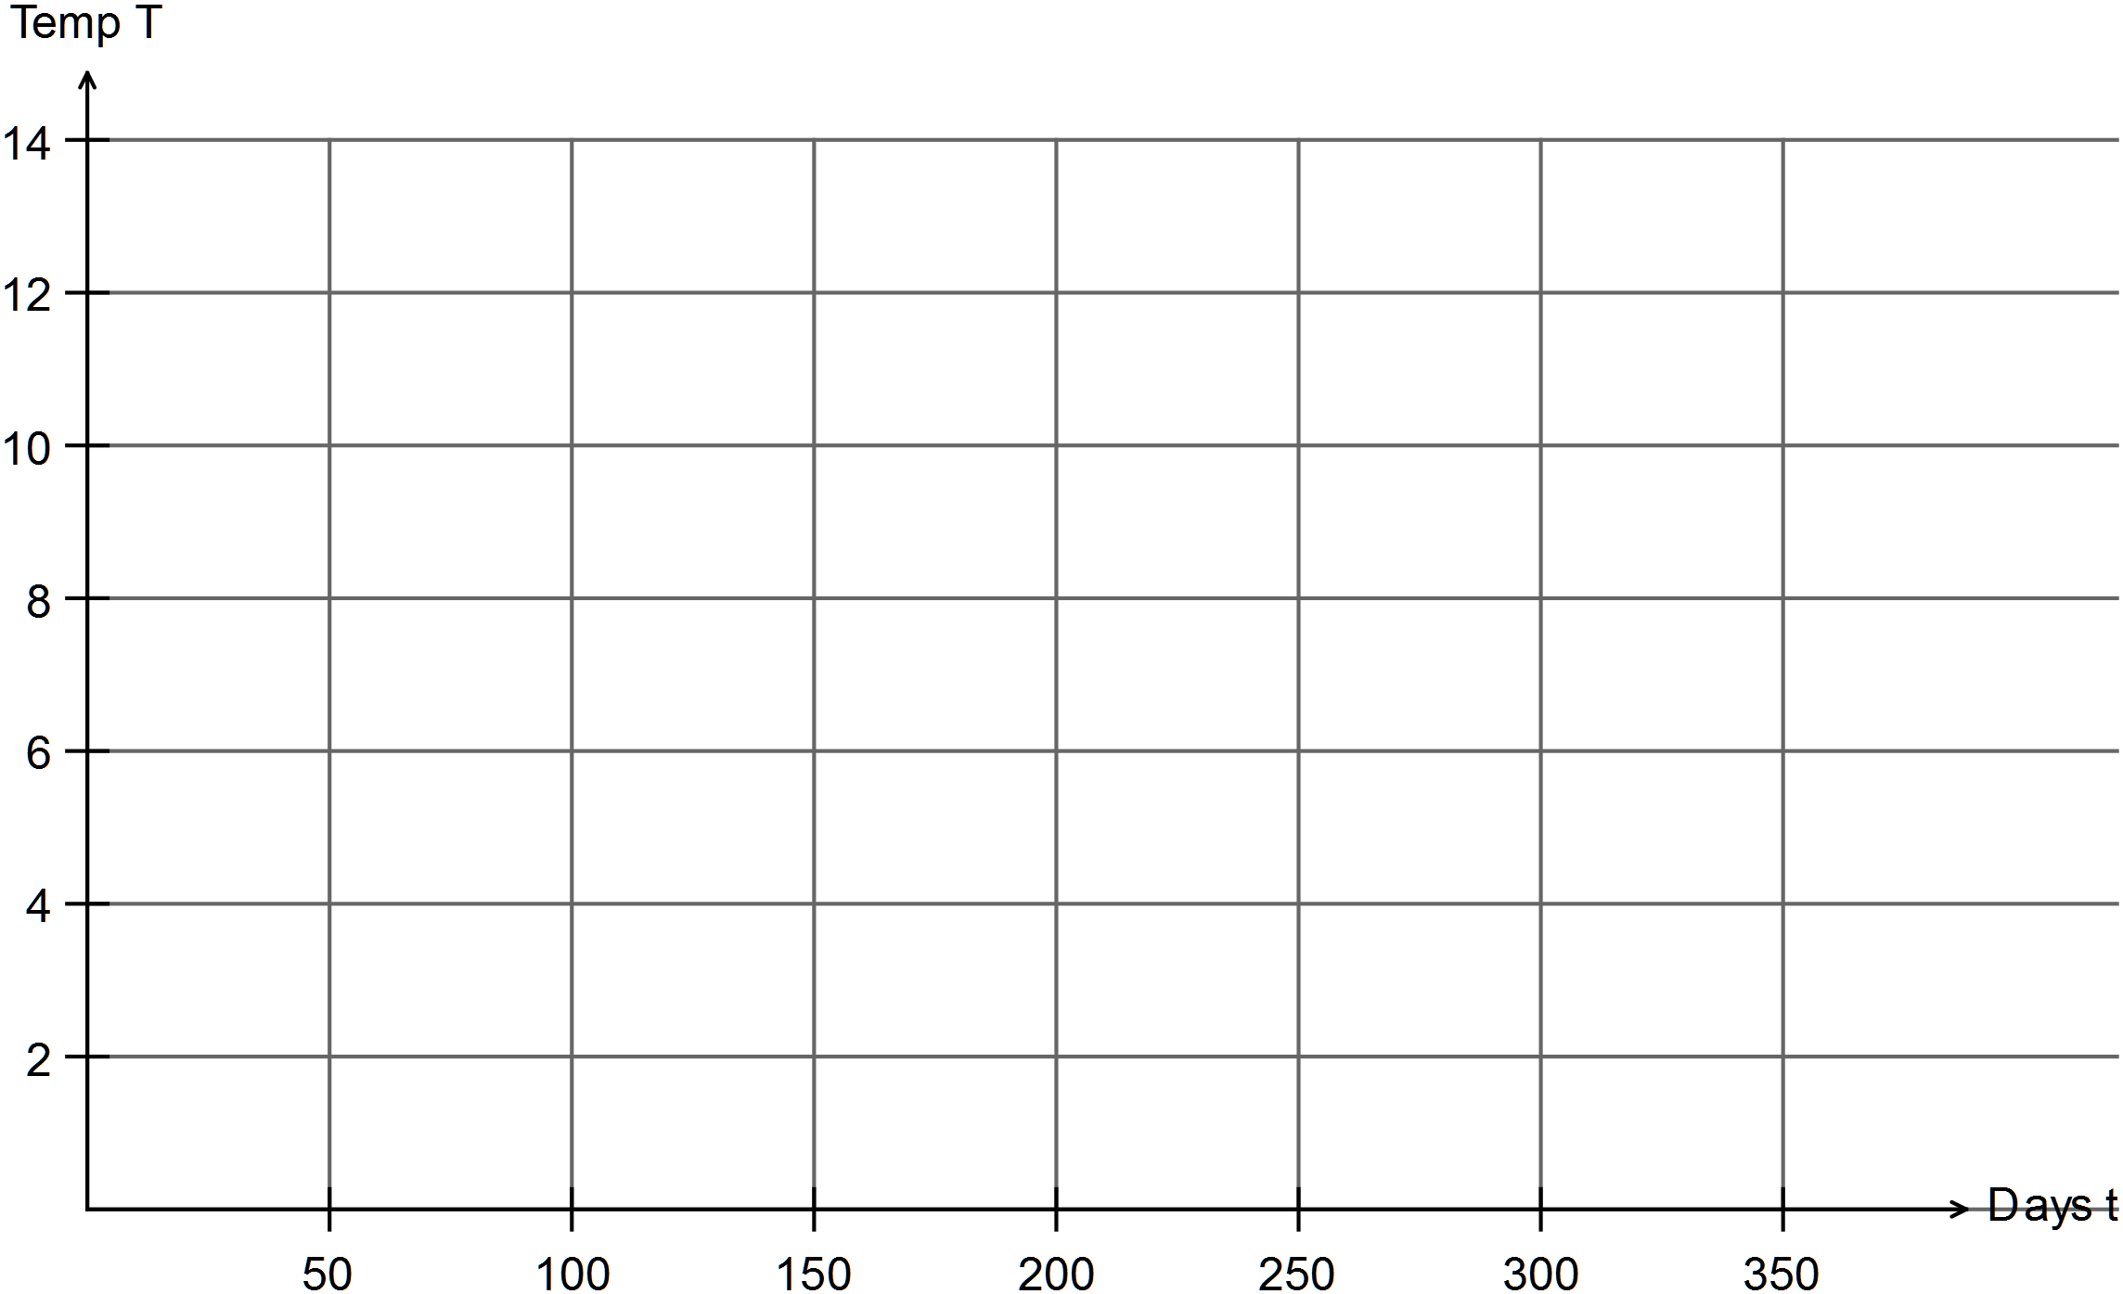

(b) How many days of sunlight are expected on March 31st? (2)

(c) What percentage of days have 12 hours of daylight or more? (2)

Question 13 (3 marks)
Prove 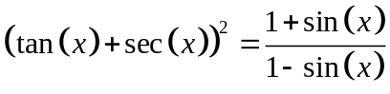 (3)

Question 14 (10 marks)
(a) Solve the following equation 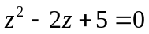. Show all working. (3)

(b) Solve the equation 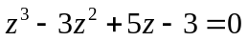. (3)

(c) (i) Given 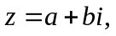 prove that 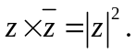 (3)

(ii) Hence determine 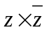 where 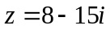. (1)

Question 15 (9 marks)
(a) Write down the contrapositive of the statement
“If avocados cost less than $4, then Susan will buy some.” (1)

(b) Write the converse of the statement “If today is a sunny day, then Terry will sit outside
with his coffee.”
(1)

(c) Prove that 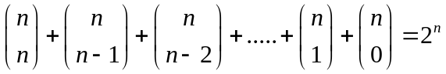 (3)
(d) Use the method of proof by contradiction to prove that there are no positive integer
solutions to the Diophantine equation 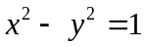. (4)

NB A Diophantine equation is an equation for which you seek integer solutions.
.

Question 16 (13 marks)
ABCD is a parallelogram. A linear transformation given by 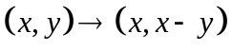transforms ABCD into the quadrilateral A’B’C’D’.

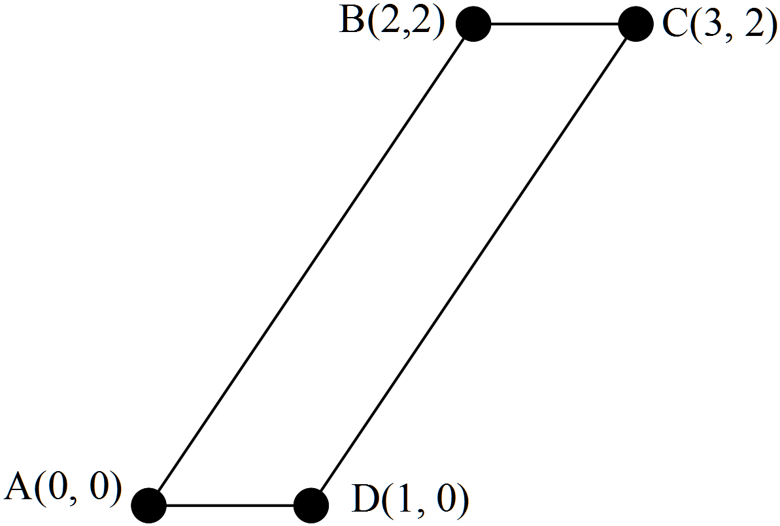

(a) (i) Write down the matrix that transforms the coordinates A, B, C and D into the coordinates A’, B’, C’ and D’. (2)

(ii) Determine the shape of A’ B’ C’ D’. (2)

(iii) Determine whether or not A’B’C’D’ can be transformed back to ABCD using matrices. (2)

(b) The parallelogram ABCD is rotated anti-clockwise through 120º, then reflected about the
y axis to obtain the image A”B”C”D”.

(i) Write down the single matrix that will perform both the transformations in the indicated order. (3)

(ii) Use the matrix found above to find the image of C(3,2) after the two transformations. (2)

(iii) Determine the matrix that transforms the image A”B”C”D” back to the object ABCD after the two transformations. (2)
Question 17 (8 marks)

It is known that the matrix M performs a reflection about the line 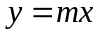
where

(a) The matrix M performs a reflection about the line .
Determine M for a reflection about the line 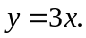 (2)

(b) Find the image of the point P(a, b) reflected about the line 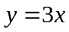. (3)

(c) Prove using a matrix method that the reflection (about a line containing the origin) of the image returns the image back to the original point. i.e. that a reflection of a reflection is itself. (3)

Question 18 (8 marks)

(a) Given the equation 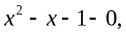 determine whether or not the solutions are rational.
(1)

(b) Prove using mathematical induction, that 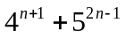 is divisible by 21. (7)

END OF SECTION TWO

